Activity 6.4.6: Troubleshooting Route Summarization

Topology Diagram
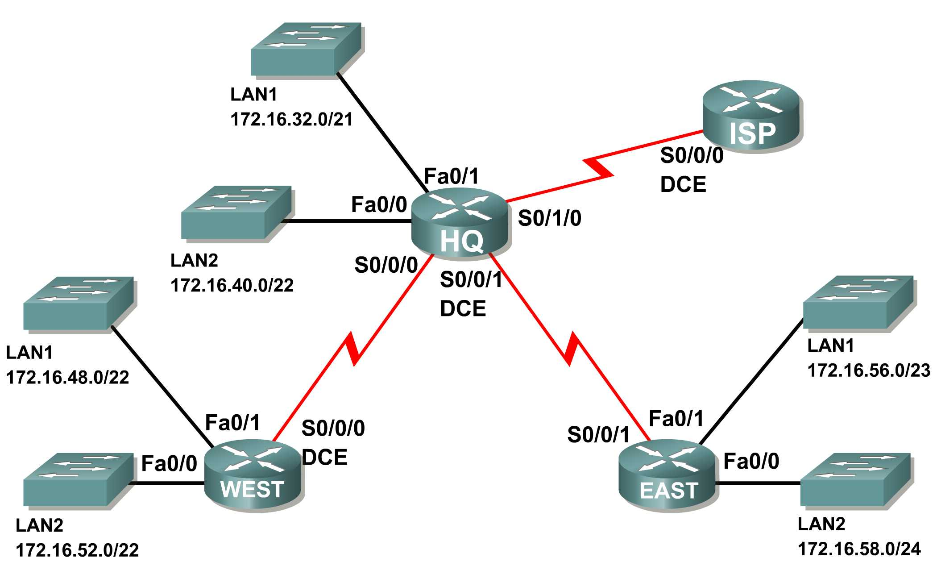
Addressing Table
Router | Summary Route | Network Address
HQ | WEST LANs | 172.16.52.0/21
HQ | EAST LANs | 172.16.56.0/23
WEST | HQ LANs | 172.16.32.0/19
WEST | EAST LANs | 172.16.58.0/23
EAST | HQ LANs | 172.16.30.0/20
EAST | WEST LANs | 172.16.48.0/21
ISP | HQ, WEST, and EAST LANs | 172.16.32.0/18

Learning Objectives
Upon completion of this activity, you will be able to:
- Discover errors in route summarization.
- Propose solutions for summarized routes.
- Document the corrected summarized routes.

Scenario
In this activity, the LAN IP addressing has already been completed for the network shown in the Topology Diagram. VLSM has been used to subnet the address space. The summary routes that are shown in the Addressing Table below the Topology Diagram are incorrect. You will need to troubleshoot the summary routes that have been assigned to determine where errors are present and determine the correct summary routes where needed.
Task 1: Examine the Summary Routes on the HQ Router.
Examine the summary routes on the HQ router and answer the questions below.
- What is the summary route for the WEST LANs? 172.16.52.0 /21
- Is this summary route correct? no
- If the route is not correct, what is the correct summary route for the WEST LANs?
172.16.48.0 /21
- What is the summary route for the EAST LANs?172.16.56.0 /23
- Is this summary route correct? no
- If the route is not correct, what is the correct summary route for the EAST LANs?
172.16.56.0 /22
Task 2: Examine the Summary Routes on the WEST Router.
Examine the summary routes on the WEST router and answer the questions below.
- What is the summary route for the HQ LANs? 172.16.32.0 /21
- Is this summary route correct? no
- If the route is not correct, what is the correct summary route for the HQ LANs?
172.16.32.0 /20
- What is the summary route for the EAST LANs? 172.16.56.0 /23
- Is this summary route correct? no
- If the route is not correct, what is the correct summary route for the EAST LANs?
172.16.56.0 /22
Task 3: Examine the Summary Routes on the EAST Router.
Examine the summary routes on the EAST router and answer the questions below.
- What is the summary route for the WEST LANs? 172.16.48.0 /21
- Is this summary route correct? yes
- If the route is not correct, what is the correct summary route for the WEST LANs?
- What is the summary route for the HQ LANs? 172.16.30.0 /20
- Is this summary route correct? no
- If the route is not correct, what is the correct summary route for the HQ LANs? 172.16.32.0 /20
Task 4: Examine the Summary Route on the ISP Router.
Examine the summary route on the ISP router and answer the questions below.
- What is the summary route for the HQ, WEST, and EAST LANs? 172.16.32.0 /18
- Is this summary route correct? no
- If the route is not correct, what is the correct summary route for the HQ, WEST, and EAST LANs? 172.16.32.0 /19
Task 5: Document the Corrected Summary Routes.
Record the corrected summary routes in the Addressing Table below.

Router | Summary Route | Network Address
HQ | WEST LANs | 172.16.48.0 /21
HQ | EAST LANs | 172.16.56.0 /22
WEST | HQ LANs | 172.16.32.0 /20
WEST | EAST LANs | 172.16.56.0/22
EAST | HQ LANs | 172.16.32.0 /20
EAST | WEST LANs | 172.16.48.0 /21
ISP | HQ, WEST, and EAST LANs | 172.16.32.0 /19

